**LED CHASER**

**AIM-**

The aim of the experiment below is to DESIGN AN LED CHASER.

I will be using an Arduino Board and a breadboard to make a circuit, one that can make four LEDs blink in a Chaser pattern.

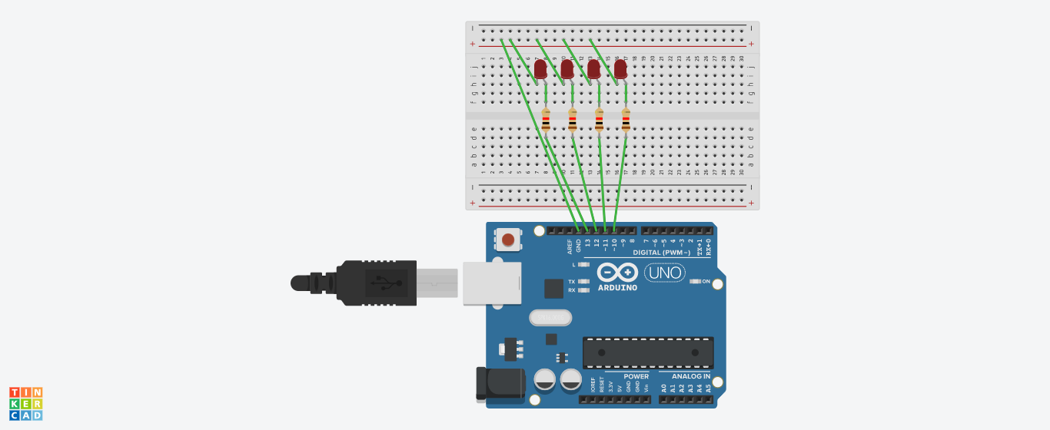

**CONCEPTS USED**

LED Chaser

Also known as dancing LEDs, it refers to a circuit which blinks LEDs in a particular pattern, so that it provides the effect of an illusion. These LED chasers are used in decorative lightning.

The LEDs light one by one for a period of the given time interval and the cycle repeats giving the running light appearance.

1. In this experiment I have used the concept of p-n junction diode that is the connections of LEDs to get the required pattern.

2. To make a circuit using Arduino Board, Bread Board and other equipment.

3. Use of resistance in the circuit.

4. Logic to code for Arduino UNO by using Loop statement.

**LEARNING AND OBSERVATIONS-**

1. Using the Arduino Board, I observed the sequence of the LEDs that were turning off and on after a regular intervals producing the effect of chasing LEDs.

2. The Arduino board can provide a supply of 5V to the chaser circuit.

3. I connected the ‘p’ terminal of the p-n junction diodes to the Digital pins 10,11,12,13 along with the resistance, and ‘n’ terminals with the ground(GND).

4. After uploading the code on the Arduino software, the LEDs started blinking and gave the effect of dancing LEDs. The LEDs were blinking in combination of two and the pattern had a time interval of 500 milliseconds.

**PROBLEMS AND TROUBLESHOOTING-**

1.The main problem that I encountered while performing this experiment was the issue of delay in the code. The LEDs were not blinking as per the instructions due to some errors in the code.

I tried various patterns and finally got the correct one.

2. The circuit was broken at one point due to the loose connection on the breadboard.

I tightened the connection by inserting the wires properly into the breadboard.

**PRECAUTIONS-**

The main precautions to be taken while performing this experiment are -

1.The LEDs need to be individually checked before connecting them to the circuit on the breadboard.

2.The codes 6in the void setup section, in the sketch, need to coincide with the connections on the hardware that is on the Arduino board.

3.When the codes are being written, the insertion of delay should not be forgotten and that too, of the required time interval.

4.In the IDE of Arduino the instructions should be given only in void loop section.

**LEARNING AND OUTCOMES**

1)I have learnt to make circuits using breadboard, Arduino board and other equipment.

2)I have learnt the various patterns that a LED chaser can do.

3)I have learnt how we can make any other type of gadgets related to this concept.

4)I have learnt how we can use the Arduino board for performing various tasks.

5)I have learnt about the elements of Arduino board and how it functions.